Book Fair 2020
Due to Covid safety restrictions this year we cannot have parents visit the Bookfair to assist with purchasing.
Please note the 2 ways in which your child can make a purchase from our Fair.
CASH
- You can simply send in the cash and the order form.
- Write down the items you wish to purchase on the order form attached and send in with the cash in a clearly marked envelope or snap lock bag (Name & class labelled)
- Your child will hand this in during their allocated shopping time. (Change is available)
- Each class has a shopping time allocated. Check on the back for your child’s timeslot.

CREDIT/EFTPOS
- You can pay BEFOREHAND at home by credit/eftpos then just send in details on the order form.
- Write down the items you wish to purchase on the order form attached and send in the form with the receipt number and amount recorded. The receipt number will be provided when you pay online. Your child will hand this in during their allocated shopping time.
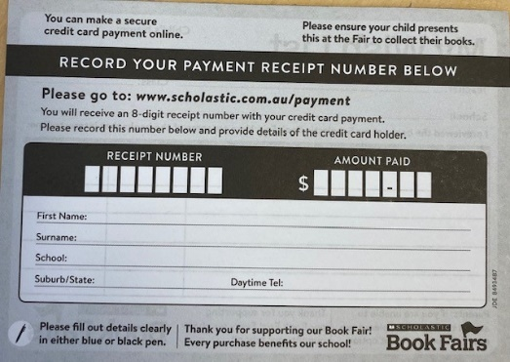
- Details on how to order online are on the back of your child’s wishlist/ Or go to www.scholastic.com.au/payment
Be sure to choose Book Fairs payment NOT Book Club
- Each class has a shopping time allocated. Check on the back for your child’s time slot.

Shopping Time Slots

Wednesday 26th August | Thursday 27th August  (Last day to purchase)
9am 4W  9.30am 6W  10 am 4M  10.30am 6M  11.45am 3W  12.15pm 5W  2pm 3M | 9am 5M  9.30am 1W  10 am 1M  10.30am 2M  11.45am KM  12.45pm KW  2pm 2W  RECESS:Catch up for any students absent on Wed

POSTERS AND STATIONERY
Please note the posters and the stationery cannot be ordered! Do not pre pay online or add these items to the order forms
Posters and stationery will be for sale at recess and lunch on Wed & Thurs until sold out
CASH ONLY
Small posters $2
Large posters $4
Stationery $1-$4
Book Fair 2020 ORDER FORM
Student’s Name | Class | Parent’s Mobile/Contact No.
You can view the books and shelf locations & prices on my Library website
Title of book | Shelf  Location | Quantity | Price
 |  | TOTAL | $

My child has cash

I have prepaid
online. I have
included the details

